NSC 4319 Test 1 Review
Chapter 1
Pin the dendrites in the picture below
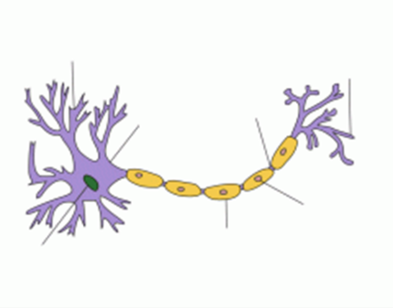
Which of the neurons below is a multipolar neuron?
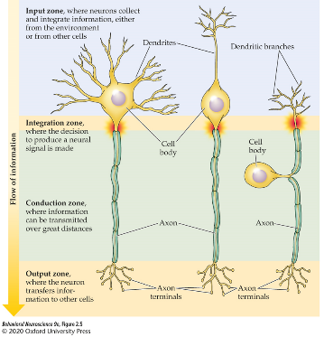
Which type(s) of glial cells can produce myelin?
Cranial nerve 9 is the _______ nerve. It controls the muscles of the throat
Motor information is carried through the _________ of a spinal nerve
The Thalamus is part of which MAJOR brain division?
Chapter 2
At rest ________ is the only ion more concentrated in the intracellular fluid instead of the extracellular fluid.
_______ is the point at which electrostatic pressure and diffusion driving ion movement are equal
the threshold of activation is the point at which __________ open
Potassium is attracted to ________ charged environments
Chapter 3
What happens to myelin during a relapse for an individual with multiple sclerosis?
What is the direction of the early current (after depolarization using voltage clamp)
briefly describe how the voltage clamp technique works
What are the two mechanisms through which conduction velocity can be increased?
The action potential primarily moves in one direction down the axon due to:

